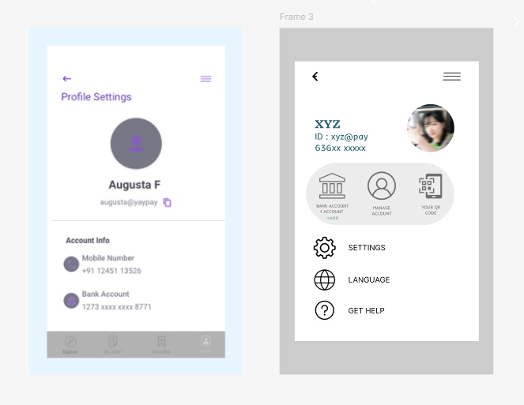

BAD DESIGN GOOD DESIGN
BAD DESIGN

It is a design which lacks Contrast.

There are more Information missing.

The fonts are dull and hard to read.

GOOD DESIGN

This design is clear and simple.

The icons make the design more easy to use.

There are many options added such as setting, language, get help and QR code which the bad design lacks. They are also the essentials needed in a profile settings.

This design provide attractive fonts ( bold and clear).

